**TRAVEL TRAX TOURS PROJECT REPORT**

**1.PROJECT INTRODUCTION**

Travel Trax Tours is a leading travel agency committed to curating unique and immersive travel experiences.

**1.1 OVERVIEW**

Travel Trax Toursbelieve that traveling is not just about the destination but the journey itself. Our purpose is to make your journeyextraordinary.

**1.2 PURPOSE**

Client comfort and peace of mind are our priorities. Immerse yourself in the rich tapestry of cultural around the world, from historical landmarks to vibrant festivals.

**2. PROBLEM DEFINITION AND DESIGN THINKING**

**2.1 EMPATHY MAP**

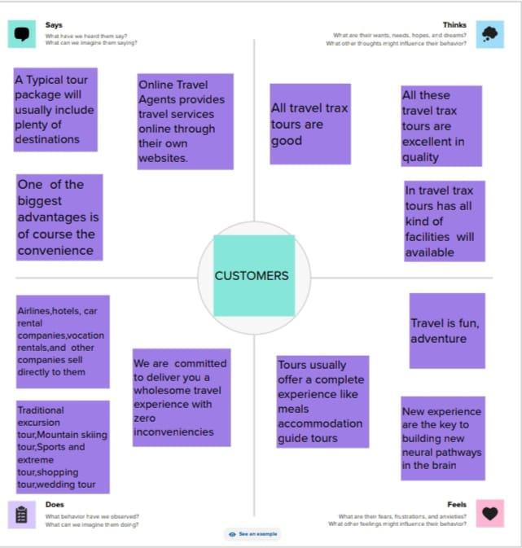

**2.2 IDEATION AND BRAINSTORM**

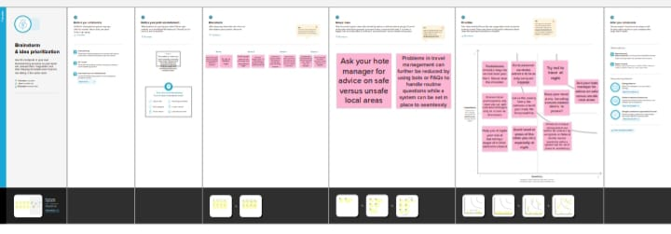

**3. RESULT**

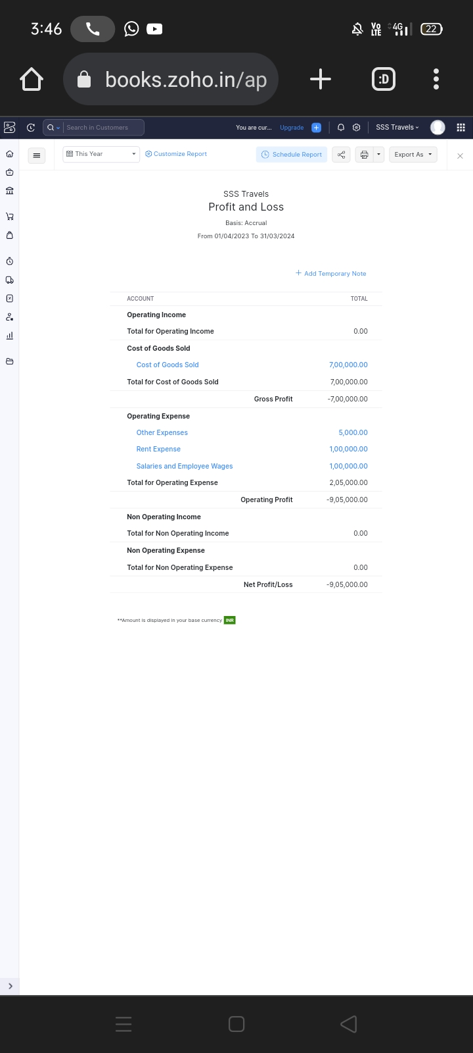

**4. ADVANTAGES AND DISADVANTAGE**

**ADVANTAGE:**

Travel Trax Tours prioritizes eco-friendly and responsible tourism, contributing positively to the places you visit while minimizing the environmental impact.

**DISADVANTAGE:**

Packaged tours can be more expensive compared to planning and booking each component of a trip individually.

**5.APPLICATIONS**

An “Travel Trax Tours” project could Satisfy your thirst for adventure with activities like hiking, rafting, and exploring stunning natural landscapes.

**6.CONCLUSION**

This program had been successfully executed.

**7. FUTURE SCOPE**

Zoho development is going to focus on cloud service.

**8.APPENDIX**

A. Source code <https://github.com/Mysa2003/Travel-Trax-Tours_18250>